- BALLAST

- Introduction
When the ship is not carrying cargo or is only lightly loaded, sufficient ballast must be carried to ensure that the ship is in a suitable condition of draught, trim, and propeller immersion to ensure safe conditions of stress and maneuverability.
National requirements must be complied with. Detailed ballast water management and reporting requirements for the United States, both federal and state, and for other countries may be found in the ship’s Ballast Water Management Manual.
- Ballast Water Management Plan
Each ship shall have on board and implement a Ballast Water Management plan. Such a plan shall be approved by the Administration taking into account Guidelines developed by the Organization. The Ballast Water Management plan shall be specific to each ship.

    - Ballast Water Record Book
- Each ship shall have on board a Ballast Water record book that may be an electronic record system, or that may be integrated into another record book or system and, which shall at least contain the information specified in Appendix II. Company vessels uses OP-44 Form for this purpose.
- Ballast Water record book entries shall be maintained on board the ship for a minimum period of two years after the last entry has been made and thereafter in the Company’s control for a minimum period of three years.
- In the event of the discharge of Ballast Water pursuant to regulations A-3, A-4 or B-3.6 in BWMC or in the event of other accidental or exceptional discharge of Ballast Water not otherwise exempted by this Convention, an entry shall be made in the Ballast Water record book describing the circumstances of, and the reason for, the discharge.
- The Ballast Water record book shall be kept readily available for inspection at all reasonable times
- Each operation concerning Ballast Water shall be fully recorded without delay in the Ballast Water record book. Each entry shall be signed by the officer in charge of the operation concerned and each completed page shall be signed by the master. The entries in the Ballast Water record book shall be in a working language of the ship. If that language is not English, French or Spanish the entries shall contain a translation into one of those languages. When entries in an official national language of the State whose flag the ship is entitled to fly are also used, these shall prevail in case of a dispute or discrepancy.
- Officers duly authorized by a Party may inspect the Ballast Water record book on board any ship to which this regulation applies while the ship is in its port or offshore terminal, and may make a copy of any entry, and require the master to certify that the copy is a true copy. Any copy so certified shall be admissible in any judicial proceeding as evidence of the facts stated in the entry. The inspection of a Ballast Water record book and the taking of a certified copy shall be performed as expeditiously as possible without causing the ship to be unduly delayed.

    - Ballast Water Management for Ships
- A ship constructed before 2009:
- With a Ballast Water Capacity of between 1,500 and 5,000 cubic metres, inclusive, shall conduct Ballast Water Management that at least meets the standard described in regulation D-1 in BWMC or regulation D-2 in BWMC until 2014, after which time it shall at least meet the standard described in regulation D-2 in BWMC;
- With a Ballast Water Capacity of less than 1,500 or greater than 5,000 cubic metres shall conduct Ballast Water Management that at least meets the standard described in regulation D-1 or regulation D-2 in BWMC until 2016, after which time it shall at least meet the standard described in regulation D-2 in BWMC.
- A ship to which paragraph 1 applies shall comply with paragraph 1 not later than the first intermediate or renewal survey, whichever occurs first, after the anniversary date of delivery of the ship in the year of compliance with the standard applicable to the ship.
- A ship constructed in or after 2009 with a Ballast Water Capacity of less than 5,000 cubic metres shall conduct Ballast Water Management that at least meets the standard described in regulation D-2 in BWMC.
- A ship constructed in or after 2009, but before 2012, with a Ballast Water Capacity of 5,000 cubic metres or more shall conduct Ballast Water Management in accordance with paragraph 1.1.
- A ship constructed in or after 2012 with a Ballast Water Capacity of 5000 cubic metres or more shall conduct Ballast Water Management that at least meets the standard described in regulation D-2 in BWMC.
- The requirements of this regulation do not apply to ships that discharge Ballast Water to a reception facility designed taking into account the Guidelines developed by the Organization for such facilities.
- Other methods of Ballast Water Management may also be accepted as alternatives to the requirements described in paragraphs 1 to 5, provided that such methods ensure at least the same level of protection to the environment, human health, property or resources, and are approved in principle by the Committee.

    - Ballast Water Exchange
- A ship conducting Ballast Water exchange to meet the standard in regulation D-1 in BWMC shall:
- whenever possible, conduct such Ballast Water exchange at least 200 nautical miles from the nearest land and in water at least 200 metres in depth, taking into account the Guidelines developed by the Organization;
- in cases where the ship is unable to conduct Ballast Water exchange in accordance with paragraph 1.1, such Ballast Water exchange shall be conducted taking into account the Guidelines described in paragraph 1.1 and as far from the nearest land as possible, and in all cases at least 50 nautical miles from the nearest land and in water at least 200 metres in depth.
- In sea areas where the distance from the nearest land or the depth does not meet the parameters described in paragraph 1.1 or 1.2, the port State may designate areas, in consultation with adjacent or other States, as appropriate, where a ship may conduct Ballast Water exchange, taking into account the Guidelines described in paragraph 1.1.
- A ship shall not be required to deviate from its intended voyage, or delay the voyage, in order to comply with any particular requirement of paragraph 1.
- A ship conducting Ballast Water exchange shall not be required to comply with paragraphs 1 or 2, as appropriate, if the master reasonably decides that such exchange would threaten the safety or stability of the ship, its crew, or its passengers because of adverse weather, ship design or stress, equipment failure, or any other extraordinary condition.
- When a ship is required to conduct Ballast Water exchange and does not do so in accordance with this regulation, the reasons shall be entered in the Ballast Water record book.

Some States have designated BWE areas that should be used as instructed by the Port State authority upon communication of the BWMS failure. The IMO lists those States and their designated BWE areas on the GISIS website:

https://gisis.imo.org/Public/BWM/ExchangeAreas.aspx

      - Ballast Water Exchange In The North Sea
Regulation B-4.2 of the BWMC allows ports States to designate areas, in consultation with adjacent or other States, as appropriate, where ships may conduct ballast water exchange. Regulation B-4.2 in BWMC determines that such sea areas can be designated in sea areas where the distance from the nearest land or the depth does not meet the parameters described in paragraph 1.1 or 1.2 of the regulation
Furthermore Norway has implemented parts of the Ballast Water Management Convention (Regulation D-1; the exchange standard) in its national regulations which entered into force on 1 July 2010. Three exchange areas have been designated within Norway´s exclusive economic zone (EEZ).
To this end a ship, on a voyage between 2 ports located in the North Sea, which under the Convention shall at least meet the standard described in regulation D-1 in BWMC, may conduct ballast water exchange in the designated ballast water exchange area in the North Sea. A ship conducting ballast water exchange in this area shall comply with all the regulations for ballast water exchange in the Convention, with the exception of regulation B-4.1 in BWMC.
A ship, on a voyage between 2 ports located in the North Sea, which under the Convention shall at least meet the standard described in regulation D-1 in BWMC, may conduct ballast water exchange in the designated ballast water exchange area in the North Sea. A ship conducting ballast water exchange in this area shall comply with all the regulations for ballast water exchange in the Convention, with the exception of regulation B-4.1 in BWMC.
The designated ballast water exchange area in the North Sea is the area with a risk index ARI of less than 0.75, the area which is not red, corrected for the "Kompromisslinie" for the Traffic Separations Scheme Terschelling-German Bight, and corrected for the Norwegian EEZ.

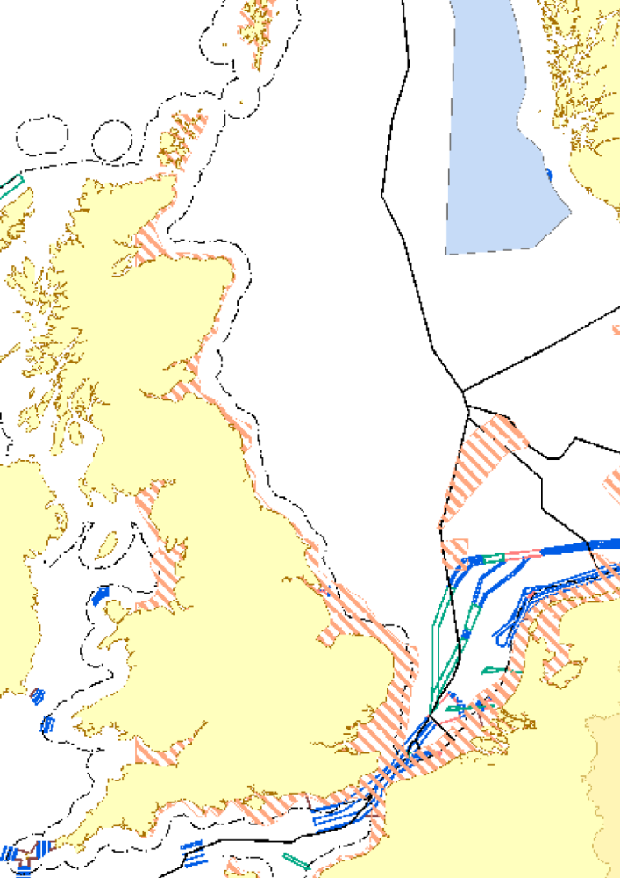

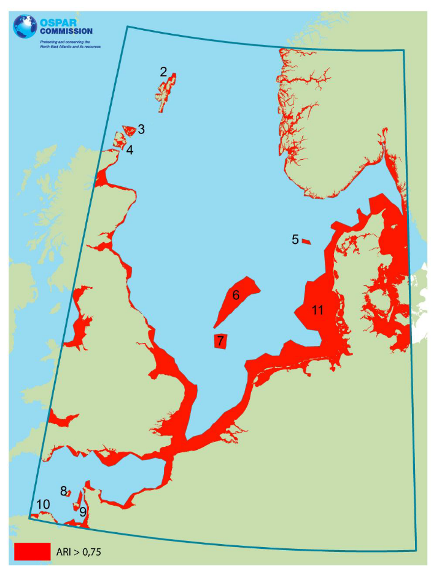

      - Ballast Water Exchange In The Caribbean

- BWM Upon entering WCR areas: Ships not meeting the ballast water performance standard contained in regulation D-2 of the Convention, or that do not have to apply the D-2 standard in accordance with the application dates set out in Rule B-3 (as amended) in the Convention, when entering the waters of the Wider Caribbean Region area, from the Atlantic Ocean or from the Pacific Ocean through the Panama Canal, should:
  - undertake ballast water exchange before entering the Wider Caribbean Region, and according to the standard set out in the D-1 Standard of the Ballast Water Management Convention, at least 200 nautical miles from the nearest land and in waters at least 200 meters in depth
  - in situations where this is not possible, either due to deviating the ship from its intended voyage or delaying the ship, or for safety reasons, such exchange should be undertaken before entering the Wider Caribbean Region area according to the standard set out in the D-1 Standard of the Ballast Water Management Convention, as far from the nearest land as possible, and in all cases in waters at least 50 nautical miles from the nearest land and in waters of at least 200 meters depth, unless other areas are designated by port States following an assessment in accordance with the Guidelines on Designation of Ballast Water Areas for Ballast Water Exchange, developed by the International Maritime Organization, and in consultation with adjacent States and all interested States as appropriate.
- BWM for ships operating within the WCR Areas: Ships not meeting the ballast water performance standard contained in regulation D-2 of the Convention, or that do not have to apply the D-2 standard in accordance with the application dates set out in Rule B-3 (as amended) in the Convention, when engaged in traffic between ports located within the Wider Caribbean Region area;
- should undertake ballast water exchange, according to the standard set out in the D-1 Standard of the Ballast Water Management Convention, as far from the nearest land as possible, and in all cases in waters at least 50 nautical miles from the nearest land and in waters of at least 200 meters depth, taking into account any Particularly Sensitive Sea Areas or Marine Protected Areas designated in the region; or
- If a port State decides to designate ballast water exchange areas, undertake ballast water exchange in areas designated by the port State for that purpose.
- Such areas shall be assessed in accordance with the Guidelines on Designation of Ballast Water Areas for Ballast Water Exchange developed by the International Maritime Organization, and in consultation with adjacent States, and all interested States.
- Ships moving between the IUCN Biographic Regions of the Wider Caribbean, that have taken on ballast water within the Wider Caribbean Region area, are encouraged to conduct BWE within the same IUCN Biographic Region where the ballast water was taken on, prior to entering and discharging ballast water in another biographic region.
- BWM outside the WCR areas: If a vessel has taken on ballast water while in the Wider Caribbean Region area and is intending to discharge ballast water outside the Wider Caribbean Region area, that ballast water should be exchanged outside the Wider Caribbean Region area, and at least 200 nautical miles from the nearest land in water at least 200 meters deep. If this is not possible for operational reasons, then such exchange should be undertaken outside the Wider Caribbean Region area in waters at least 50 nautical miles from the nearest land, in waters of at least 200 meters depth.
- Tanks to be exchanged: While only those tanks that will be discharged in Wider Caribbean Region areas would need to undergo ballast water exchange following the procedure in paragraphs 1, 2 and 3, ballast water exchange of all tanks is encouraged for all vessels that have the potential/capacity to load cargo in the Wider Caribbean Region, as changes in routes and planned activities may occur.
- Sediment Management:
- Release of sediments during the cleaning of ballast tanks should be avoided in Wider Caribbean Region areas.
- For Company vessels Sediments collected during the cleaning or repairing operations of ballast tanks should be delivered in sediment reception facilities during dry dock process
- Exemptions: Exemptions may be granted to a ship on a voyage between specified ports or locations within the Wider Caribbean Region area, or to a ship operating exclusively between specified ports or locations within the Wider Caribbean area. These exemptions are to be granted according to Regulation A-4 1 of the Ballast Water Management Convention, and based on the Guidelines for risk assessment under regulation A-4 of the BWM Convention developed by the International Maritime Organization.
- Safety and Stability: If the safety of the ship is in any way jeopardized by a ballast exchange, it should not take place. Additionally, these guidelines do not apply to the uptake or discharge of ballast water and sediments for ensuring the safety of the ship in emergency situations or saving life in the Wider Caribbean Region areas. As per Regulation B-4 of the Ballast Water Management Convention, if the safety or stability of the ship is threatened by a ballast water exchange operation, this operation should not be undertaken. The reasons should be entered in the ballast water record book and a Report should be submitted to the maritime authorities of the Port of destination.
- BWM Plans: Each vessel calling at a port within the Wider Caribbean Region area should have on board a Ballast Water Management Plan complying with Guidelines for Ballast Water Management and Development of Ballast Water Management Plans developed by the International Maritime Organization, and should keep a record of all ballast water operations carried out.
- BWM Reports: Ships not meeting the ballast water performance standard contained in regulation D-2 of the Convention, or that do not have to apply the D-2 standard in accordance with the application dates set out in regulation B-3 of the Convention (as amended), and do not conduct ballast water exchange prior to entering the waters of the Wider Caribbean Region area from the Atlantic Ocean or via the Panama Canal from the Pacific Ocean, should enter the reasons in the ballast water record book and a Report should be submitted to the maritime authorities of the Port of destination.
- Governments are encouraged to exchange information on invasive marine species or anything that will help change the perceived risk associated with ballast water and sediment.
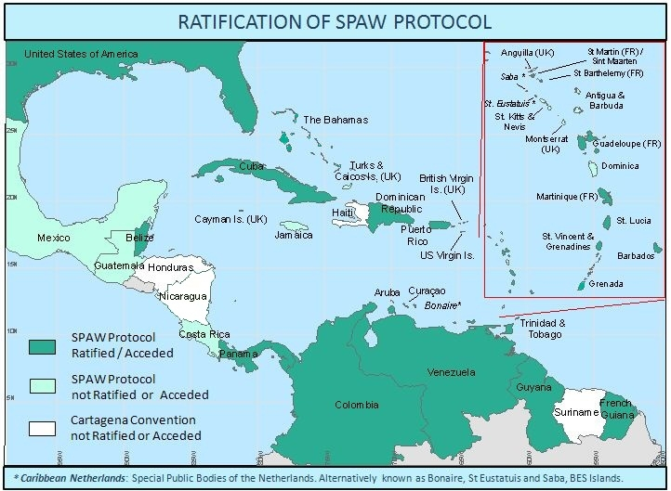

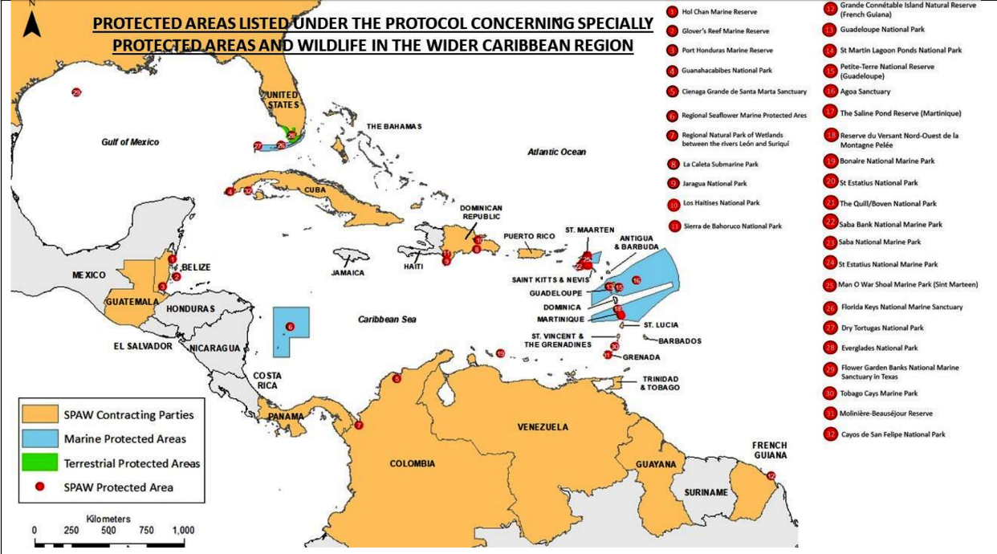

    - Sediment Management for Ships
- All ships shall remove and dispose of Sediments from spaces designated to carry Ballast Water in accordance with the provisions of BWMC. For company vessels the sediment in WBTs of ship delivered to shore during dry dock process.
    - Duties of Officers and Crew
Officers and crew shall be familiar with their duties in the implementation of Ballast Water
Management particular to the ship on which they serve and shall, appropriate to their duties, be familiar with the ship’s Ballast Water Management plan.
    - Stability/Stress/FSM calculations for ballast exchange

When changing ballast at sea, care must be taken to avoid overloading the ship, or straining the hull by uneven distribution of weights in ships where the pipeline system does not permit the simultaneous loading and discharging of ballast, it will be necessary to carry out these operations alternately. It is important that all persons are warned of the deeper loading that will occur in these circumstances on what is otherwise regarded as a light ship passage.
The special care procedures required for pollution prevention when carrying out ballast exchange operations is highlighted below:
- Masters are reminded that proper stability considerations must be in place before any mid-ocean ballast exchange takes place. The complexity of exchange sequences on certain vessels pose very real safety concerns as human error and equipment failure could potentially endanger the vessel.
- Cargo Form 20 BALLAST EXCHANGE PLAN, should be filled and approved by Master prior exchange operations. Form should be sent to company prior the operation for final reviewal by using MPM Operation Module , Cargo Plan List Section.
- A risk Assessment should be completed prior to this operation shall minimum include
- Bridge visibility standards (SOLAS V/22);
- Propeller immersion; and
- Minimum drafts forward.
- Max free surface moment
- BM/SF Limitations
- Sloshing effect (If Applicable)
- Stability condition

The company has the policy to always use the approved method as per vessel Ballast Water Management Plan when changing ballast at sea
A ballast exchange plan for a ballast voyage should be prepared in advance, in a similar manner to the preparation of a cargo plan for a loaded voyage, and with the same degree of thoroughness. This pre-planning is necessary in order to maintain safety in case compliance with ballast exchange or other ballast water treatment or control options is required by port authorities.
Safety considerations
The IMO Resolution A.868 (20) includes guidance on safety aspects of ballast water exchange at sea. The safety points outlined below are intended to emphasise that the consequences of an inadvertent error at sea can be more significant than the same error made in port. Ballast water exchange at sea is a comparatively new development, and a sense of familiarity with the mechanics of ballasting should not be allowed to induce complacency in this new procedure.
The ships Trim and Stability Manual and Ballast Management Manual shall always be considered when changing ballast water at sea. Prior to Ballast water exchange detailed stability calculations should be carried out, by using vessels loading computer. Free surface effects, and vessels stress calculations should be within the limits during whole exchange operation.
When changing ballast water using the Sequential Method maximum two ballast tanks shall be discharged or loaded at the same time.
Ship’s position, weather forecast, machinery performance and degree of crew fatigue shall be considered
before changing ballast water. If any factors are considered unfavourable the ballast exchange should be suspended or halted, and the reason to be logged in the Ballast Reporting Form and Deck Log Book.
    - Ballast water treatment
Invasive Aquatic Species in ship’s ballast water is one of the biggest problems faced by the shipping industry. Posing a great threat to the marine ecosystem, these aquatic species has led to an increase in bio-invasion at an alarming rate. Under IMO’s “International Convention for the Control and Management of Ship’s Ballast Water and Sediments”, implementation of ballast water management plan and ballast water treatment system on board ships has thus become important.
A variety of technologies are available in the market for treating ballast water on ships. However, constraints such as availability of space, cost of implementation, and level of environmental friendliness play an important role in usage of a particular type of ballast water treatment system.
A number of factors are taken into account for choosing a ballast water treatment system for a ship. Some of the main factors taken into consideration are
- Effectiveness on ballast water organisms
- Environment-friendliness
- Safety of the crew
- Cost effectiveness
- Ease of installation and operation
- Space availability on board

The main types of ballast water treatment technologies available in the market are:
- Filtration Systems (physical)
- Chemical Disinfection ( oxidizing and non-oxidizing biocides)
- Ultra-violet treatment
- Deoxygenation treatment
- Heat (thermal treatment)
- Acoustic (cavitation treatment)
- Electric pulse/pulse plasma systems
- Magnetic Field Treatment
A typical ballast water treatment system on board ships use two or more technologies together to ensure that the treated ballast water is of IMO standards.
Every vessel should use and carry out maintenances of the Ballast water treatment system as per manufacturars instructions.
Physical Separation/ Filtration Systems Ballast Water Treatments
Physical separation or filtrations systems are used to separate marine organisms and suspended solid materials from the ballast water using sedimentation or surface filtration systems. The suspended/filtered solids and waste (backwashing) water from the filtration process is either discharged in the area from where the ballast is taken or further treated on board ships before discharging.
The following equipment are mainly used for ballast water filtration:
Screens/Discs : Screens (fixed or movable) or discs are used to effectively remove suspended solid particles from the ballast water with automatic backwashing. These are extremely environmentally friendly as they do not require usage of toxic chemicals in the ballast water. Screen filtration is effective for removing suspended solid particles of larger size but is not very handy in removing particles and organisms of smaller sizes.
Note: It has been noticed that though screens are highly effective in removing majority of suspended solid particles and organisms from ballast water, they alone are not sufficient to treat the ballast water according to IMO standards.

Hydrocyclone : Hydrocyclone is an effective equipment for separating suspended solids from the ballast water. High velocity centrifugal force is used to rotate the water to separate solids. As hydrocyclone doesn’t have a moving part, it is easy to install, operate and maintain on board ships.
Note: It has been found that as the operation of hydrocyclone heavily depends on the mass and density of the particle, they are not successful in removing smaller organisms from the ballast water.

Coagulation : As most of the physical filtration methods are not able to remove smaller solid particles, the method of coagulation is used prior to the filtration process to join smaller particles together to increase their size. As the size of the particles increase, the efficiency during the above mentioned filtration processes increases. Such treatment involving coagulation of smaller particles into small flocs is known as flocculation. The flocs settle more quickly and can be removed easily.
Note: Some ballast water treatment systems using coagulation and flocculation utilize ancillary powder (sand, magnetite etc.) or coarse filters to produce flocs. An additional tank is required for treating ballast water for this process and thus extra space is required on board ships.

Media Filters : Physical ballast water treatment systems with media filters can also be used in order to filter out smaller sized particles. It has been found that compressible media filters (Crumb rubber) are more suited for shipboard use because of their compact size and lower density as compared to conventional granular filtration systems.
Magnetic Field Treatment
The magnetic field treatment uses the coagulation technology. Magnetic powder is mixed with the coagulants and added to the ballast water. This leads to the formation of magnetic flocs which includes marine organisms. Magnetic Discs are used to separate these magnetic flocks from the water.

Chemical Disinfection (Oxidizing and non-oxidizing biocides) Ballast Water Treatments
Biocides (Oxidizing and non-oxidizing) are disinfectants which have been tested to potentially remove invasive organisms from ballast water. Biocides removes or inactivates marine organisms in the ballast water. However, it is to note that the biocides used for ballast water disinfectant purpose must be effective on marine organisms and also readily degradable or removable to prevent discharge water from becoming toxic in nature.
On the basis of their functions, biocides are mainly divided into two types:
- Oxidizing
- Non-Oxidizing
Oxidizing biocides : Oxidizing biocides are general disinfectants such as chlorine, bromine, and iodine used to inactivate organisms in the ballast water. This type of disinfectants act by destroying organic structures of the microorganisms such as cell membrane or nucleic acids.
Non-oxidizing biocides : Non-oxidizing biocides are a type of disinfectants which when used interfere with reproductive, neural or metabolic functions of the organisms.
Oxidizing Biocides
Some of the processes utilizing oxidizing biocides used on board ships are:
Chlorination – Chlorine is diluted in water to destroy the micro-organisms.
Ozonation – Ozone gas is bubbled into the ballast water using an ozone generator . The ozone gas decomposes and reacts with other chemicals to kill organisms in the water.
Other oxidizing biocides such as chlorine dioxide, peracetic acid, and hydrogen peroxide are also used to kill organisms in the ballast water.
Non-Oxidizing Biocides
Though there are several non-oxidizing biocides available in the market, only a few such as Menadione/ Vitamin K are used in ballast water treatment system as they tend to produce toxic by-products. A lot of research is being made in this field to make more non-oxidizing biodes feasible for use in ballast treatment plant.
Ultra-Violet Treatment Method
Ultraviolet ballast water treatment method consists of UV lamps which surround a chamber through which the ballast water is allowed to pass. The UV lamps (Amalgam lamps) produce ultraviolet rays which acts on the DNA of the organisms and make them harmless and prevent their reproduction. This method has been successfully used globally for water filtration purpose and is effective against a broad range of organisms.

De0xygenation
As the name suggests, the deoxygenation ballast treatment method involves purging/removing of oxygen from the ballast water tanks to make the organisms asphyxiated. This is usually done by injecting nitrogen or any other inert gas in the space above the water level in the ballast tanks.
Note: It generally takes approximately 2-4 days for the inert gas to asphyxiate the organisms. Thus, this method is usually not suitable for ships having short transit time. Moreover, such type of systems can be used on ships with perfectly sealed ballast tanks. If a ship is already installed with an inert gas system, then a deoxygenation system will not require more space on board ships.
Heat Treatment
This treatment involves heating the ballast water to reach a temperature that will kill the organisms. A separate heating system can be utilized to heat the ballast water in the tanks or the ballast water can be used to cool the ship’s engine, thus disinfecting the organisms from the heat acquired from the engine. However, such treatment can take a lot of time before the organisms become inactive and would also increase the corrosion in the tanks.
Cavitation or Ultrasonic Treatment
Ultrasonic energy is used to produce high energy ultrasound to kill the cells of the organisms in ballast water. Such high pressure ballast water cavitation techniques are generally used in combination with other systems.
Electric Pulse / Plasma Treatment
The electric pulse /plasma for ballast water treatment is still in the development stage. In this system, short bursts of energy are used to kill the organisms in ballast water.
In the pulse electric field technology, two metal electrodes are used to produce energy pulse in the ballast water at very high power density and pressure. This energy kills the organisms in the water.
In electric plasma technology, high energy pulse is supplied to a mechanism placed in the ballast water, generating a plasma arc and thus killing the organisms.
Both these methods are said to have almost the same effect on the organisms.
Any by-products of the process from any type of systems to be conducted as per manufacturer guidance and in accordance with local and international regulations

- Ballast Management
During the vessel’s Ballast Operations the following items must be taken into consideration, by both Master and Chief Officer:
- Calculate stability and ensure it is sufficient. Also ensure longitudinal stresses to not exceed limits
- During ballasting and de-ballasting, ensure the ballast loading/unloading rates are within the limits of vessels pump/line/ballast tank venting arrangement.
- Maintain sufficient drafts forward at sea
- Avoid partly filled ballast top side tanks and especially ballast holds
- Choose light or heavy weather ballast and change, if necessary, according to conditions change
- Check ballast tanks soundings daily so as to detect problems timely, and record all soundings in the deck log book and the sounding book
- Commence de-ballasting before arrival at loading berth if sea-keeping, air-draft, and longitudinal stress allow. The ballast/Re-ballast as per international regulations and instructions of vessel’s ballast water management plan.
- Special care should be taken, when vessel is icebound, for blocked air/sounding pipes
- Drain ballast tanks dry, if possible. Presence of water in TST accelerates corrosion
- When ballasting continuously in rivers and estuaries, the amount of sediment will increase vessels constants and should be removed when possible (during Dry-docking, long voyages, lying idle)
- Ensure air pipes are not blocked
- Close tanks properly and verify doors watertight especially in not frequented quarters
- Vessels fitted with Ballast Water Treatment System should only use the system for Ballast Management as per their Ballast Water Management Plan.
- Check tank atmosphere before entering and follow enclosed space entry procedures
- Tank entry should not be permitted immediately after ballast treatment operation conducted. At least 3 hours ventilation is required and additional consideration as per the fitted system specifications on board is required with following enclosed space entry procedures.
- Every vessel should use the ballast systems ( lines/pumps/vents/valves etc. ) strictly in accordance with vessels Ballast water management plan, P&A manual and manufacturers instructions.
Chief Officer and Chief Engineer are responsible for supervising the use of the BWMS and Only trained deck officers and engine officers are permitted to use the BWMS

    - Ballasting and De-ballasting
Ballasting and deballasting must be planned and programmed around the cargo operations so as to avoid exceeding specified draught, trim or list requirements, while at the same time keeping shear force, bending
moments and metacentric height within prescribed limits.
Ballasting:
In general, there are no restrictions on ballasting Segregated Ballast Tanks (SBT) during the cargo discharge operation. However, the following considerations should be taken into account:
- Ballast should be taken as necessary to meet air draught requirements on the berth, particularly when hard cargo arms are connected.
- Ballast should not be loaded if it may cause the ship to exceed the maximum safe draught for the berth.
- Loading of ballast should not cause extreme shear forces or bending moments on the ship.
- Care should be taken to ensure that excessive free surface is not allowed to occur as this may result in the ship assuming an angle of loll, thereby jeopardising the integrity of the loading arms.
- Ballast tanks should never be filled more than %98 by volume. Ballast tank levels should be monitored during cargo/ballast and ballast exchange operations to avoid overfilling. Remote gauging system alarms for Ballast tanks should be set at %95 by volume and ballast filling should be stopped when tank reaches %95 by volume.

De-Ballasting:
To avoid pollution due to contaminated segregated ballast, the surface of the ballast should be sighted, where possible, prior to commencing deballasting. When segregated ballast is being discharged, it is prudent tomonitor the ballast being discharged over board by means of a ballast water monitor. This may give the earliest warning of any inter-tank leakage between cargo and ballast tanks that may have been undetected,
or even have been undetectable, before starting the ballast operation. As an additional precaution, on commencement of deballasting, a visual watch should be established to observe the ballast as it discharges into the sea. The operation should be stopped immediately in the event of contamination being observed. Prior to discharge overboard, the surface of ballast water in tanks adjacent to cargo or bunker tanks, or where oil pipes, including hydraulic lines, pass through the tank to be inspected.
In case ballast water found contaminated, or evidence of migration of liquid between cargo, ballast, bunker, void or cofferdam spaces all operations to be stopped immediately and M4 Emergency Manual Scenario 26 to be followed.
During any ballast pumping operation, due regard must be paid to the dangers of cargo tank pressurization. A number of pressurization incidents have occurred in various ships which have led to severe structural damage and expensive repairs.
Care must be taken not to operate pumps above the maximum safe rate when handling bulk ballast in this regard the pumping capability of the ballast pumps must be borne in mind with respect to the maximum loading rates when ballasting any given tank or set of tanks.
When ballasting at sea and if the weather conditions are so severe that it would be dangerous to expose staff for extended periods on deck to monitor ballasting rates, it may be more prudent to consider running in ballast by gravity to a number of tanks.
Should it become necessary to ‘pump up’ the ballast tanks within a short space of time of starting to run in from the sea, care should be taken not to under estimate the amount of ballast which will have ‘run in’ prior to starting the pumps, when calculating the pumping time requirement.
8.3.1.1 Hammering effect
During ballast water or liquid cargo handling operations, always handle the valves and pumps with care so that there is no sudden change in the pressure or the flow rate of the liquid. Remote controlled valves opening and closing times should be set as per manufacturers instructions. Manually controlled valves should be operated within the closing and opening time limits of manufacturer. Opening and closing time of the valves should be posted in CCR.
Common Procedures
- For offsetting “Negative pressures” in relevant pipelines to prevent the “Water Hammer Effect ”
Confirm the pressure in the ballast line is “Positive” by the suction gauge on Water Ballast Pump (hereinafter “WBP”) or Water Ballast Eductor (hereinafter “WBED”).
If the line pressure is “Negative”, the following is required to avoid a” Water Hammer” which may be caused by the negative pressure at the initial stage of ballasting : make the line pressure positive prior to ballasting by slightly opening (10% / crack open) the suction valve of the empty ballast tank or the overboard discharge valve which is above the water line.
Note on the in-line-pressure judgment. When the ship’s trim is more than usual and the water remains in the line as well, there is a possibility that the suction gauge does not indicate the negative pressure. The remaining water in the ballast line near the pump may cause the gauge to indicate positive pressure, though the other end of line is under extreme negative pressure.
- Procedure for leading water in the lines / Filling up water in WB suction pipes :
Prior to start of ballasting, the relevant lines should be filled up with sea water to prevent the acceleration of the water flow in the ballast suction line. Confirming above (1), open the Water Ballast Pump sea-chest valve 10 % (Slight open) to lead seawater into the line. Moreover, stop operation of the valve until: i) The Water Ballast Pump suction gauge indication corresponds to the water head of the Ship’s draft and indicates a stable reading. ii) Confirm sea water comes out from the Air purge cock on the suction strainer of WBP.
Letting in the water to WBP through sea chest valve:
Priming the suction line of WBP through the sea-chest valve is for preventing the occurrence of “Water Hammer” because of the short water flow distance between the BWP and the valve.
If the intermediate valve opening is not available, adjust the working speed of the valve as per diameter value such as less than one inch (25mm) per 3 seconds (For example: 96 sec. for the valve with diameter of 800 mm)
- Prevention of “Surging” / the existence of “Air lump in the line”
When the process AA. and BB. are complet the ballast suction line is filled up with sea water and it is confirmed is at a positive pressure, the “Water Hammer” possibility is quite low, it is the time to proceed Line-up for ballasting on a full scale.
In the meantime, countermeasures for preventing “Surging” possibly triggered by “Air lump” in the line shall be carried out. The line-up should be done observing following basic practices.
Priming the ballast suction line with sea water, ensure successful air purging.
To avoid accelerating water flow in the ballast suction line, start the ballasting operation from the closest tank to the WB sea chest valve, and the de-ballasting from the closest tank to WBP (or WB overboard discharging valve).
To ease the impact of “Surging” by extraction of “Air lump” in the ballast suction line, gentle gravity shall be used for checking water-heads.
Principle procedure to “Stop” the ballast operation by gravity When sustaining Ballasting, De-ballasting or Shifting ballast water internally by gravity, close from the furthermost valve to upstream water source one by one (i.e. from the lowest water-head to higher water-head) so as not to detain enormous volume of air in the ballast suction line.
Preventing “Liquid block” in suction lines
On a ballast voyage of bulk carriers, when suction lines are filled with water, the suction-filling valve of one of the Water Ballast Tanks shall always be open as a precaution against “Liquid block”; so that the pressure inside ballast line does become negative.
*“Liquid block” is the boosting of internal pressure by liquid volume expansion in closed pipe space due to temperature rise. Sometime, excessive “Liquid block” results in damages to the valve seat ring or other, thus care should be taken to avoid a liquid block in any pipe.
    - Segregated Ballast
Segregated ballast tanks are a MARPOL 73/78 related requirement for new ships under that Convention. Such ships should make full use of the facility to reduce time alongside and minimise light ship stresses. Tanks should be filled concurrently with discharge of cargo, taking care that the draught and trim remain within acceptable limits, and must be discharged before loading has been completed.
Loose scale should be removed periodically. The relevant provisions of the tank entry permit must be strictly adhered to before entry into segregated ballast tanks is made.
It is a Statutory Requirement that where the overboard discharge for segregated or clean ballast takes place below the waterline, the surface of the ballast water in the tanks must be examined immediately before discharge to ensure that no contamination with oil has taken place
Venting arrangements of segregated ballast tanks must be checked prior to commencing ballasting operations. Vents are again to be checked after starting the operation to confirm free ventilation.
S.B.T. may be filled to 100% of required capacity but overflow of ballast is to be avoided especially in the case of double bottom tanks.
If oil contamination of S.B.T. is detected then all precautions should be taken to ensure no oil or oily water mixture is discharged over side.

    - Simultaneous Handling of Cargo and Ballast

When ballasting/de-ballasting is done concurrent with cargo operations the cargo plan shall include a ballasting/de-ballasting plan. The ballasting/de-ballasting plan shall also be depicted by use of the bar diagram in the cargo plan and shall include considerations regarding the draft, trim and stresses the vessel is subjected to during the operation. Planning for ballast operations shall include comprehensive and detailed plans related to heavy weather ballasting of designated cargo tanks, where applicable.
Any additional information like restrictions of ballast operation due to carriage of heated cargoes, restrictions due to stresses or increase d free surface effect shall be indicated in the Cargo Plan.
Stability and Stress information
The bar diagram shall be used to indicate the planned stresses that the vessel will be subjected to during the operation. The maximum allowable shears force/bending moment, limitations if any on the number and location of slack tanks and other relevant information shall be indicated in the cargo plan.
    - Discharge of Ballast to Shore Tank Reception Facilities
MARPOL 73/78 requires all contracting states to provide reception facilities for oil residues and mixtures. These facilities must be provided at oil loading terminals, repair ports and other ports where ships have oil residues and mixtures to discharge and must be sufficient to meet the needs of oil tankers and other ships without causing undue delay.
The Government of each Party of Convention is required to notify the International Maritime Organisation (IMO) where reception facilities in ports are alleged to be inadequate. The IMO has approved a two part report form, the first about the port and the second about the reporting ship which Parties are asked to bring to the notice of ships flying their flags. The following reporting procedure has been agreed by IMO:
- The Master of a ship faced with a lack of adequate reception facilities is asked to complete and submit through the ship-owner, to the National Authority, Part 1 of the form describing the inadequacy. This may be supported, if appropriate, by the completed Part II where the Master has had to make other arrangements in consequence it would be helpful to those providing reception facilities if, before making such a report, the Master brought the alleged inadequacy to the attention of the Harbour Authority. He would then only need to make a report if the allegation is incapable of resolution in which case the name and rank of the port official to whom the matter was referred should be included with the report.
- The Authority will evaluate each report received and, where in its opinion the allegation of inadequate facility is justified, it will:
- In the case of foreign ports inform the port state of the alleged inadequacy and also inform the IMO Secretariat by means of annual summary reports; and
- In the case of domestic ports take up the matter of the alleged inadequacy directly with the port and terminal concerned.
- The Secretariat of the IMO Marine Environmental Protection Committee will transmit the information received to the Governments of the countries where the alleged inadequacies arose.
- The Government receiving such information will submit to IMO comments or other information relating to the alleged inadequacy.

Harbour Authorities and Terminal Operators who provide reception facilities or others with whom an authority has an agreement to provide them may make a reasonable charge for their use. The owner of a ship is required to pay those charges unless he has an agreement with the owner of the cargo that the latter will meet those costs. Conditions for the use of the facility may be laid down so long as those conditions are reasonable. The Master of any ship using any facilities is obliged to advise the operators of the facility in writing of the quantity and content of any oil residues or other noxious liquid substances to be discharged before the discharge takes place. It is of course in the interests of Masters to operate their vessels in a way which keeps the quantities to the minimum possible.
Whenever a ship discharges residues to shore reception facilities, the Master should obtain a certificate, whenever possible, from the terminal confirming the quantity and type of residues discharged. This requirement is additional to the statutory entries to be made in the Oil Record Book.
Please also see ship specific Ballast Water Management Plan & Bio fouling Management Manual.
    - Pollution Prevention Requirements - Ballast
Ballasting is considered by the company to be a critical operation where:-
- There is a high risk of transporting water containing living organisms that may constitute a natural disaster if released in a coastal area other than where the organisms were found.
- Oil may be introduced onto the sea via deballast operations The special care procedures required for pollution prevention when carrying out ballasting operations is highlighted below:
For overboard discharge of engine room bilge water or tank ship slops refer to the current MARPOL requirements for the type of vessel.
The requirements of the IMO Ballast Handling Guidelines, MARPOL and the companies Ballast Management and EMS Manual are to be complied with.
This will include the proper operation and use of any oily water separators or detection units and overboard ballast decontamination or sediment removal devices (if fitted).
Additionally port state, local authority, national regulations and, or terminal directions are to be complied with.
The company requires that:
Ballast handling is to comply with instructions in the vessels operational manuals, MARPOL P&A manuals and the companies Ballast Management Manual.
Stresses and Bending Moments during ballast handling must always remain within limits. Trims and lists should not become extreme or dangerous.
Ballast must be checked or inspected to stop or reduce the potential for oil pollution into the sea by ballast water and the following guidelines emphasised:
Prior to arrival in port ballast pipes and dedicated ballast sea-chests are to be flushed through to ensure no discoloured water will be sighted on start-up of de-ballast operations.
- Prior to any DE ballasting:
- A visual inspection of the ballast water is to be carried out to ensure there is no oil on top. This may be done visually, electronically (UTI, MMC, etc.) or by other methods (sampling the surface with clean white rags, etc.).
- A notice to this effect is to be permanently marked at the ballast pump controls.
- Sampling via tank sounding pipes may not be a proper indicator of oil contamination where the sounding pipe is solid.
- Where manhole covers or tank vents heads are removed then these must be properly re-secured after inspection.
- Where inspection is by overflowing to confirm no oil on top then ensure the tanks are not over pressurised.
- A stock of oil finding paste is to be carried on board.
- A check of tanks adjacent to ballast tanks to be made to ensure no transfer has occurred.
- On commencement, during and on completion (stripping of tanks) of De-ballasting the area around the vessel is to be checked for signs of oil.
- All those involved in the ballasting process be aware of procedures and ensure the Chief Officer’s instructions are followed properly.
To Note:
The vessel must at no stage be placed in danger to accomplish the requirements for ballast control. This includes stress and bending moment limits, the placing of chemicals (e.g. calcium hypochlorite) that may damage the vessel or toxic or dangerous chemicals that may injure the crew.
Where the Master is encountering difficulty complying with local or international rules the company is to be consulted for assistance.
It is company policy not to discharge oil or contaminated water other than what is permitted by current law (MARPOL). Furthermore where water from oil tanker cargo spaces is discharged it must be through an ODME device. If any oil pollution is suspected then all operations are to cease and the vessels oil pollution emergency action plan is to be activated.

- Ballast Operations
    - Heavy Weather Ballast
The Masters of the Fleet vessels are also equipped with the overriding authority to take ballast into identified cargo / oil tanks according to Trim & Stability Booklet in heavy weather and sea conditions without waiting for any company orders.
It is imperative that Masters and officers should be aware that partially loading a cargo/oil tank with heavy weather ballast may present a potential problem due to “sloshing”. The combination of free surface and the flat tank bottom can result in the generation of wave energy of sufficient power to severely damage internal structure and pipelines.
Heavy Weather Ballasting must be always conducted as per MARPOL, IMO requirements and with the methods described in the Trim-Stress and Stability Booklet of each vessel.

The Master should determine the factors (weather, sea state or stresses-stability conditions) that would make him to proceed with the Heavy Weather Ballasting operation.

Contingency planning it’s necessary and should be included into the discharging-loading operation plans, in order that the vessel should always have the dedicated tank(s) crude oil washed and very well drained after the latest discharging operation, ready for any potential case.

Operational Procedures for Before Exposed to Heavy Weather and Sea Conditions
- Heavy weather Ballast Plan Form (CARGO-20A) Should be prepared and approved by master before heavy weather ballasting. Form should be sent to company for final reviewal by using MPM Operation Module , Cargo Plan List Section .
- Stress, stability, trim, sloshing and FSM effects should be calculated by loading master computer based system and should be recorded to the plan.
- All doorways and other openings through which water can enter/expose into the hull or deckhouses, etc, should be closed adequately being weather and water tight in adverse weather conditions and accordingly all outfits for this purpose should be maintained on board,
- Weather and water tight hatches, door, manholes, sounding pipes etc. should be kept adequately closed during navigation, except when necessarily to open for working at this places and should always be ready for immediate closure in safely and this places should be clearly marked to indicate that these fittings are to be kept closed during navigation,
- Ventilation pipes and closing appliances of fuel tanks should be secured,
- Reliance on automatic steering by auto pilot may be dangerous, which may prevent ready to changes to course that may be needed,
- In all conditions of loading, necessary care should be taken to maintain a seaworthy freeboard according to load line regulations,
- The speed should be reduced, if excessive rolling, propeller knocks/ cavitation, shipping of sea water on deck or heavily slamming occurs. Six heavy slamming or 25 propeller knocks/cavitation during 100 pitching motions should be considered as dangerous,
- When the ship sailed with direction of waves following or quartering seas, special attention should be paid, because of dangerous phenomena such as parametric resonance, reduction of stability on the wave crest, and excessive rolling may occur singularly, in sequence or simultaneous in a multiple combination, creating a threat of capsize. Particularly, when the wave length is of the order of 1.0 to 1.5 times ship’s length, this is a dangerous case. Ship speed and/or course should be altered appropriately to avoid the case,
- Sea water trapping in deck wells should be avoided. If freeing ports are not sufficient for the drainage of the well, the speed of the ship should be reduced or the course change, or both. Freeing ports provided with closing appliances should always be capable of functioning and are not be locked,
- The master should be aware that steep or breaking waves may occur in certain areas, or in certain wind and current combinations. (River estuaries, shallow water areas, funnel shaped bays, etc.) These waves are particularly dangerous, especially for small ships,
- All portable equipment / appliances on the open deck or closed areas should be adequately secured,
- Use of operational guidelines for avoiding dangerous situations in heavy weather and seas conditions or/and loading master computer based system is recommended.
Before ballasting or de-ballasting in port, the operation should be discussed and agreed in writing between the Responsible Officer and the Terminal Representative.
The specific agreement of the Terminal Representative must be obtained before non-segregated ballast takes place.
Ballast must be loaded and discharged in such a way as to avoid the ship’s hull being subjected to excessive stress at any time during the operation.

    - Loading Ballast into Cargo/Oil Tank
When loading ballast into cargo/oil tanks, the following precautions should be observed:
• Before taking ballast into cargo/tanks containing hydrocarbon vapour, the Responsible Officer should consult with the Terminal Representative and all safety checks and precautions applicable to the loading of volatile petroleum must be observed. Closed loading procedures should be followed.
• On crude oil tankers, any cargo/oil tank to be ballasted should be crude oil washed beforehand.
• When taking ballast into cargo/oil tanks that contain hydrocarbon vapour, gas is expelled this may be within the flammable range on mixing with air. This gas should therefore be vented through the recognized venting system.
• When taking ballast into cargo/oil tanks that previously contained cargoes that required closed operations, the ballast should also be loaded “closed” by following the procedures in Trim & Stability Booklet.
• Ballast should not be loaded over the top (and overfill alarm should not be activated) into cargo/oil tanks containing hydrocarbon vapour.
• If the vessel received heavy weather forecast at her voyage area before arrival at discharging port, during discharging or after departed from disport on the way, If the master decided on ballast taking into cargo/oil tanks, the master should decide on before entering the heavy weather area with enough time for completion safely ballasting operation. The vessel should be safely assembled the relevant rigging as spool piece accordingly between cargo sea lines and ballast suction lines in CPR.
• Always the connection rigging between cargo sea lines and ballast suction lines in CPR with suitable wrenches and equipment should be ready to connect and disconnect in safely as soon as quickly in case of in needed and already connection equipment should be stowed safely at the closest location in CPR.
• When starting to ballast, cargo pumps should be operated so that no oil is allowed to escape overboard when sea suction valve is opened.
• Ships fitted with an inert gas system must replace the ballast discharged from cargo/oil tanks with inert gas, so as to maintain the oxygen content of the tank atmosphere at not more than 6 % by volume.
• All cargo/oil tank ballast discharged at sea must be discharged in accordance with MARPOL.
    - Shore Line Flushing
Some terminals require that to flush shore line with sea water via segregated ballast systems of vessel to clean the line and provide a water plug in shoreline. On tankers with segregated ballast, this requires the cross-connection of the cargo and ballast systems, or direct connection of ballast manifolds to the shore cargo line, with the attendant risk of contamination between the systems unless a deck manifold for ballast is fitted.

Operators should produce carefully considered procedures for managing this operation, which should address the following issues:

- Fitting of cross-connection.
- Cargo line setting procedure.
- Ballast pump operation.
- Segregation of ballast and cargo.
- Removal of cross-connection and isolation of the systems.

A detailed risk assesment should be carried out / documented and office permission should be gained prior shoreline flushing operations.
    - Ballasting in Sub-Zero Temperatures

The very cold environment at sea, could cause the ballast water, air and vent pipes, valves and section lines to freeze. If ice chunks fall from the tank sides after the discharge of the liquid ballast, they may damage coatings or components. It is unlikely that any sizeable tank will freeze solid since ice acts as an insulator; however, ice cannot be discharged when the vessel is loading and causes the deadweight capacity to be reduced.
Ballast water in tanks above the waterline in vessels may freeze starting from the top of the tank and at the sides. The extent of the freezing will depend on the salinity of the ballast water and the temperatures encountered. Higher salinity water should be used as fresh and brackish water freezes more easily than high salinity water. The type of water used will depend on local and regional environmental regulations along the route.
To reduce the risk of ballast water from freezing, minimize the amount of ballast water that is carried high in the vessel. Placing the seawater systems low in the vessel and away from ice flow lines, having some way to separate ice from the water while pumping in water, and re-circulating hot water/steam at the inlet areas helps prevent freezing in the system and from ice entering the tank. Bubble systems help prevent freezing and can be used in temperatures as low as –30°C.
Ballast water tanks:
- Ballast tanks must not be filled completely to avoid freezing.
- In general, pump out minimum 10% after filling (consider the possible free water surface effect of the vessel’s stability).
- Be aware that the tank ventilation deck valve and ventilation pipe could freeze and hamper the free airflow to and from the tank resulting in over/under pressure of the tank.
- Side tanks containing ballast are much more exposed to freezing in extreme weather, especially when installed above the water line. Great care should be taken if any water is required to be kept in side tanks. If possible side tanks should be kept empty, or only partly filled if necessary.
- Change the ballast for clean seawater if tanks contain freshwater or brackish water.
- Check the chain lockers for water and pump out prior to reaching the cold area.
- Always check the ballast water surface against freezing prior to start deballasting to avoid under pressure in the tank. Also if tank is partly loaded check the water surface against freezing prior to start ballasting to avoid overpressure in the tank
Seawater inlet suctions:
- Check and test if there is air supply connected to sea chest in order to blow out ice if necessary.
- Check if steam can be supplied to your sea chest for heating in case freezing starts.
- Use one inlet only, preferably the lower one, and keep the other on stand-by

    - Cargo Tank Leakage Into Double Hull Spaces
When dangerous bulk liquid cargo is suspected to have leaked into double hull spaces the following priority actions shall be considered/taken:
- Check the atmosphere in the double hull space to establish the content of flammable and/or toxic vapour in its atmosphere. It is essential that the atmosphere readings are taken at different levels, at as many points as possible, in order to establish the profile of the double hull space’s atmosphere. Identifying the cargoes involved and the risks of associated with them.
- Notify the Company
- If flammable gas is detected in a double hull space, there are a number of options which can be considered to maintain the double hull space atmosphere in a safe condition:
- Continuous ventilation of the double hull space.
- Inerting the double hull space.
- Securing the double hull space with flame screens in place at the vents.
- A combination of the above.
If the double hull space is ventilated or inerted in lieu of filling, it should be sounded regularly to ascertain the rate of liquid build-up and thus of leakage.
If it is found necessary to inert the double hull space, the operation shall be carried out in accordance with the guidelines provided in ISGOTT below:
- The hose string shall be electrically continuous, and this shall be verified prior to its use.
- In order to minimise the transfer of hydrocarbon vapour from cargo tanks all cargo tank inert gas block valves, where fitted shall be temporarily closed.
- Prior to inerting the double hull tank space the inert gas line shall be purged with inert gas, the hoses ( flexible inert hose) shall not be connected until this is done.
- After the double hull space is inerted, it should be kept topped under positive pressure and the oxygen content not exceeding 6% by volume. Considerations shall be given to keeping the inerting hose permanently connected to the inert gas system. This ensures:
  - Constant pressure monitoring by the IG system.
  - Over pressure monitoring by the p/v breaker.
  - Ease of topping up.
- The sealing of double hull space openings shall be checked to ensure air is not let into the tank.
- Atmosphere measurements of the double hull space shall be monitored from all designated points of the tank.
If the quantity of cargo leaking into the space is determined to be pumpable, it should be transferred to a suitable cargo tank via safe and segregated arrangements.
Entry into the double hull space is prohibited until it is safe for entry and there is no further possibility of ingress of dangerous gases and/or vapours.
- Ensure all efflux gases arising from inerting/ventilating the double-hull space is vented at least two metres above the deck by rigging a stand pipe arrangement at the air pipe of the double hull space, after removing the vent head and installing P/V valve (including flame screens).
- Maintain a close monitoring watch on the double hull space until the cargo tank from which the leak has occurred is empty and repairs are conducted in a safe manner.

    - Transfer cargo from Double Hull
If the quantity of cargo leaking into the double hull space is determined to be pumpable, it shall be transferred to another available cargo or slop tank, as applicable, to minimise the contamination of the space and to facilitate subsequent cleaning and gas freeing operations.

The following shall be complied with during such transfer operation:
- Vessel shall, as far as practicable, inform the Company prior any transfer of cargo from the double dull spaces, along with the suggested plan of action for the transfer.
- All precautions shall be taken to avoid any contamination of cargo that may occur as a result of such transfer. However, if transfer is deemed to be absolutely necessary to ascertain the safety of the vessel, such transfer shall be carried out irrespective of the risk of cargo contamination.
- As far as practicable transfer shall be done to an empty cargo or slop tank to avoid cargo contamination.
- The effect on the stability of the vessel due to such transfer shall be verified prior commencement of transfer. The stability of the vessel shall be ensured during all stages of cargo transfer from the double hull space.
- The transfer shall, as far as practicable, be carried out using the emergency ballast/cargo spool piece connection. Emergency ballast/inert gas system connection subject to vessels specific double hull spaces inerting procedure.
- If the double hull space is maintained in an inerted condition, the inert gas plant shall be in operation during such transfer.
- The tank into which the cargo is being transferred shall, as far as practicable, be maintained in an inert condition.
- During the transfer, all electrostatic precautions detailed in ISGOTT and TSG (Chemicals) shall be complied with.
- If necessary usage of portable fans.
- Filling or partially filling ballast tanks with ballast.

    - Ballasting for Tank inspection
BALLASTING, CARGO AND BALLAST TANKS FOR INSPECTION OR SURVEY IS NOT PERMITTED BY COMPANY.

- Ballast Water Contingency Measures
    - IMO’S Ballast Water Management Convention
      - Background
This section covers contingency measures that may be considered when a vessel is trading either between Party States of the BWMC, to a Party State or is registered with an Administration that is a Party State. This section should be implemented together with the ship BWMP.
In July 2017, the IMO issued BWM.2/Circ.62, ‘Guidance on Contingency Measures under the BWM Convention’.BWM.2/Circ.62 defines a contingency measure as, ‘…a process undertaken on a case-by-case basis after a determination that ballast water to be discharged from a ship is not compliant, in order to allow ballast water to be managed such that it does not pose any unacceptable risks to the environment, human health, property and resources.’
The IMO’s Guidelines for Ballast Water Management and the development of Ballast Water Management Plans (G4), Resolution MEPC.127(53), do not specifically include contingency measures. However, BWM.2/Circ.62 states that in the case of non-compliant ballast water, the ship and the Port State should consider the contingency measures contained in the Ballast Water Management Plan (BWMP) of the ship. As such, the measures and details provided in this document are proposed as examples for inclusion in a ship’s BWMP.
In more recent discussions at the IMO, a distinction has been made between the use of contingency measures when a BWMS fails due to a mechanical or technical problem and the use of contingency measures when the
uptake water has challenged the BWMS and non-compliant ballast water has therefore been taken up. For the
management of the non-compliant ballast water in both situations, the contingency measures that will need
to be considered by the ship remain similar. As such the options provided in this document may be considered
under both circumstances.

      - Reporting
The following communications are required in the event of a BWMS failure:

- Using the company’s defect reporting procedure, the responsible officer should report to the company. Also Annex I: Model BWMS Failure Reporting should be send
- The company should report the BWMS failure to the Flag Administration, the BWMS manufacturer and the Class Society.
- Based on feedback from the Flag Administration and the BWMS manufacturer the company should
agree on a BWMS Repair Plan which would include all relevant supporting information, including
historical failure and a schedule with a specific timeline for the repair to be completed (see below)
- The company should submit a Ballast Water Contingency Measure Request Form to the Port State
authority where the ballast water is intended to be discharged. The Ballast Water Contingency Measure
Request Form should include a copy of the BWMS Failure Reporting Form, the BWMS Repair
Plan and any other relevant documentation regarding the incident (see Annex I: Model Ballast Water
Contingency Measure Request Form).
- Based on the previous points, the company should confirm to the ship which Contingency Measure is to be undertaken and provide any additional guidance or instructions necessary to fulfil the requirements of the Port State authority, Flag Administration or Class Society, as necessary.
      - Expectations of each Party
In the event of a failure of a BWMS the communications and actions taken to resolve the issue will include
the following stakeholders:

1. Company, designated person ashore
Having received the BWMS Failure Reporting Form from the responsible officer on the ship, the designated person ashore – technical manager will need to coordinate the necessary response between the Port State authority, the Flag Administration, the BWMS manufacturer and the Class Society, as necessary. It is important to open communications as soon as possible with the Port State authority at the ballast discharge port. The result of the coordination will be the development of the BWMS Repair Plan as well as the submission of the Ballast Water Contingency Measure Request Form to the relevant Port State authority. Any necessary actions to be undertaken as advised by the Port State authority or the Flag Administration would be undertaken by the company and relayed to the ship.
2. Port State Authority
On receipt of the Ballast Water Contingency Measure Request Form and associated information, the Port State authority is expected to relay its consent to undertake the Contingency Measure proposed by the company or offer an alternative contingency measure together with clear guidance on how the measure is to be undertaken and any additional reporting requirements that may need to be made prior to the vessel entering the Port State’s waters.
3. Flag Administration
On being advised of the BWMS failure by the Company, the Administration should acknowledge receipt of the report and accept that the report itself will act as notification of the failure. The Company should request that the Administration issue a dispensation to the vessel for an appropriate length of time acknowledging the failure of the BWMS and noting the BWMS Repair Plan and the implementation of the contingency measures.
Please note that some Administrations have chosen to retain the authority to issue the International Ballast Water Management Certificate (IBWMC) and not delegate it to Class Societies. This includes the
review and approval of the BWMP.
4. Class Society
When appointed as the recognised organisation by the Administration, the Class Society’s role is to approve the BWMS installation and issue the IBWMC. In issuing the IBWMC, the approval will have included the Ballast Water Management Plan and its contingency measures. The BWMP should have been updated with the contingency measures upon installation of the BWMS or on delivery with the BWMS for new buildings.

In the event of a BWMS failure, the issuing authority for the IBWMC will investigate and decide whether a survey is necessary and instruct the Class Society accordingly (see Regulation E-1.7 of the BWMC).
An additional Class Society survey may only be necessary following a significant repair of the structure, equipment, systems, fittings, arrangements and material necessary to achieve full compliance with the BWMC.
5. BWMS Manufacturer
The BWMS manufacturer is expected to provide a BWMS Repair Plan to the Company which includes
specific details on the type of failure and the repair proposed, together with a clear timeframe for when the repairs are to be undertaken and completed.
    - United Coast Guard Regulations
      - Background
The United States is not a Party to the IMO’s BWMC. The USCG requirements in §151.2040, ‘Discharge of
ballast water in extraordinary circumstances’, state the following:

If the installed BWMS required by this subpart stops operating properly during a voyage, or the vessel’s
BWM method is unexpectedly unavailable, the person directing the movement of the vessel must ensure
that the problem is reported to the nearest COTP or District Commander as soon as practicable. The
vessel may continue to the next port of call, subject to the directions of the COTP or District Commander,
as provided by part 160 of this chapter.

(1) The Coast Guard will normally allow a vessel that cannot practicably meet the requirements of
§151.2025(a)(1) of this subpart because its installed BWMS is inoperable, or the vessel’s BWM method is
unexpectedly unavailable, to employ one of the other ballast water management (BWM) methods listed
in §151.2025(a) of this subpart.

(2) If the master of the vessel determines that the vessel cannot employ other BWM methods due to the
voyage or safety concerns listed in paragraph (a) of this section, the Coast Guard will normally allow the
vessel to discharge ballast water in areas other than the Great Lakes and the Hudson River north of the
George Washington Bridge.

(3) If the Coast Guard approves such an allowance, the vessel must discharge only that amount of ballast
water operationally necessary to ensure the safety and stability of the vessel for cargo operations. Ballast
water records must be made available to the local COTP upon request.

To assist in the practical application of the above regulation, in February 2018 the USCG issued Policy Letter
18-02, ‘Guidelines for evaluating potential courses of action when a vessel bound for a port in the United States has an inoperable ballast water management (BWM) system’. This Policy Letter should be taken into account when developing Contingency Measures for the ship’s BWMP. A summary of the key points of the
Policy Letter 18-02 follow:
1. The BWMP should address what the vessel will do if the BWMS is inoperable. As such, contingency measures should be included in the BWMP and be specific to the vessel, its operational profile, route, voyage duration and capabilities. Even though the USCG does not require the BWMP or the Contingency Measures to be class approved, there is some merit in doing so to ensure compliance with the IMO BWMC. When making the notification to the USCG (that the BWMS is inoperable), the Master/Company should present proposed alternatives to the use of the BWTS. As noted in MSIB 007-17, Acceptable U.S. Ballast Water Management Methods vs. BWM Convention Methods (issued June 30, 2017), the USCG do not consider exchange as an acceptable BWM method for vessels beyond the compliance date specified.
2. The guidance applies to vessels that are using a USCG type approved BWMS or a BWMS accepted by the USCG as an AMS.

3. A vessel with an inoperable BWMS that has not passed its compliance date may use any of the ballast water management (BWM) methods listed in §151.1510(a) or §151.2025(a). Such a vessel remains eligible to claim the route exemption allowed by §151.2040(a) and not perform BWE if its voyage will not take it beyond 200 nautical miles from shore for enough time to perform BWE. The compliance date in respect to this Policy Letter is also used to mean the Extended Compliance Date.
4. A vessel that HAS passed its compliance date and has an inoperable BWMS may use one of the other methods outlined in §151.2025(a). However, if the vessel intends to use BWE then it must attain approval from the District Commander or the COTP first. The route exemption allowed by §151.2040(a) is not available to a vessel using BWE under this circumstance.
5. The BWMP should also outline the procedure for consulting with the Captain of the Port (COTP) and reporting to the National Ballast Information Clearinghouse (NBIC), see below. Note however that reporting to the NBIC does not substitute for notification to the COTP in the event of a BWMS failure, or if the vessel’s BWM method is unexpectedly unavailable. The role of the Smithsonian NBIC is simply as a contractor engaged to collect vessel reports, and to perform research & analysis of same. Receipt or confirmation of successful transmission of a BWM report is an indication that the data was reported in good order and not approval of the actions reported. As noted in Contingency Measure CM.9, the USCG COTP may propose the alternative compliance option of partial loading and offshore (beyond 12 nm from shore) de-ballasting.
6. A lack of consumables, e.g. active substance chemicals that render the BWMS inoperable does not meet the intent of ‘stops operating properly’ as used in §151.1510 or 151.2040 and will not be justification to employ an alternative management method.
7. The details listed in Annex I ‘Model Ballast Water Contingency Measure Request Form’ will provide useful
Information for the USCG to respond to the vessel. The USCG stresses the importance of including repair details in the request and as such the BWMS Repair Plan should also be included with the Contingency Measure request. The COTP will use this information to confirm the BWMS meets the “unexpectedly unavailable” threshold under §151.2040(b). Specifically, the COTP needs to determine if attempts to repair the BWMS are supported by communications with the manufacturer and other compliant ballast water management methods are available
8. A vessel past its compliance date and reporting its BWMS as inoperable for the first time may be allowed to use BWE in lieu of using the BWMS, provided the COTP is notified in advance and BWE is acceptable to the COTP. An inoperable BWMS on subsequent voyages will have to report: 1) the date of the most recent repair, 2) the date and location of when the BWMS was last operable, and 3) crew training records demonstrating competency in the operation and maintenance of the BWMS.
9. Any vessel past its compliance date must repair its BWMS before returning to the US after sailing in foreign waters.

As with other instances of potential noncompliance, if a vessel is discovered to not be in compliance with the
Regulations, the COTP may impose operational controls that restrict the vessel’s movement or cargo operations, a monetary penalty, and a higher priority consideration for future examinations. Restrictions in cargo operations can be significant and include port, agent or pilot fees, additional fuel costs, and cargo delays. There is also the potential for prosecution if there is evidence of criminal intent.
      - Reporting
The reporting process laid out in section 8.5.1.5 is fundamentally the same when vessels need to discharge ballast water in US territorial waters, with the key difference being that the COTP will act as the Port State authority. As such the USCG Regulation provides that if the vessel’s installed BWMS stops operating properly during a voyage, or the vessel’s BWM method is unexpectedly unavailable, the vessel owner/operator must report the problem to the nearest COTP as soon as practicable. It is also recommended the vessel owner/operator contact the COTP at the next port of call, if different to the nearest COTP, as soon as practicable. The vessel may continue to the next port of call, subject to the directions of the COTP.

The USCG is clear that the COTP will confirm which contingency measure is acceptable. Because of the need to receive explicit confirmation from the relevant COTP, sufficient time is required if the decision is to undertake
BWE in compliance with the USCG BWE standard, i.e. 200nm from the baseline (coast).
A brief statement regarding the failure should also be included in the Electronic Notice of Arrival (ENOA) 96 hours prior vessel arrives US waters and to both the nearest COTP as soon as possible and before the vessel enters US waters. There is limited space in the ENOA and current experience suggests that the recipients may respond and request the submission of further documentation relating to the failure by email.

In addition and as previously noted, the company must also continue to report to the NBIC.

    - Contingency Measures
The following contingency measures are considered practical management options to be taken in the event a
BWMS fails on a fleet vessel. Master and Company consideres each measure and decided for the specific vessel based on its operational profile and design limitations whenever needed.

GUIDANCE ON THE APPLICATION OF THE BWM CONVENTION TO SHIPS OPERATING IN CHALLENGING WATER QUALITY CONDITIONS

The primary purpose of this Guidance is to assist ships in planning for compliance with the BWM Convention and the D-2 discharge standard when a type-approved ballast water management system (BWMS) that has been properly installed, operated and maintained encounters operational limitations or has difficulty meeting operational demand in challenging water quality (CWQ) conditions. This Guidance includes recommended steps that can be taken to restore or maintain effective operation of a BWMS when operating in CWQ. These include steps to identify when a system is inoperable owing to CWQ; actions to avoid bypass of the system; steps to recover from bypass including steps to return to compliance with the D-2 discharge standard; and planning, record-keeping and communication principles.

The BWMP should provide that, when a ship encounters CWQ, an evaluation of ship safety should be conducted prior to the application of any steps to manage CWQ as included in this Guidance. Any safety risks identified should be evaluated to determine mitigating actions.

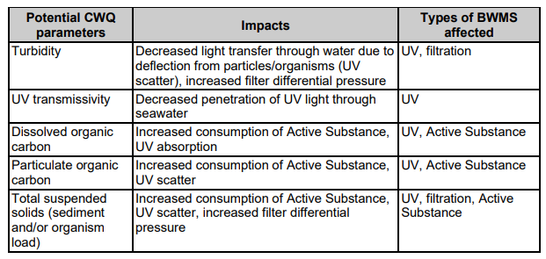
Alternatives should be tried before the ship bypasses a BWMS, because bypass increases the risks ballast water poses to the environment, human health, property and resources. Bypass also increases the operational workload for ship crew to perform alternative management methods and subsequently return the BWMS and ship to normal operations for D-2 compliance.

Before the BWMS is bypassed ensure that any BWMS alarm that could be ascribed to CWQ is not due to other factors such as malfunction, maintenance, crew familiarity or experience.

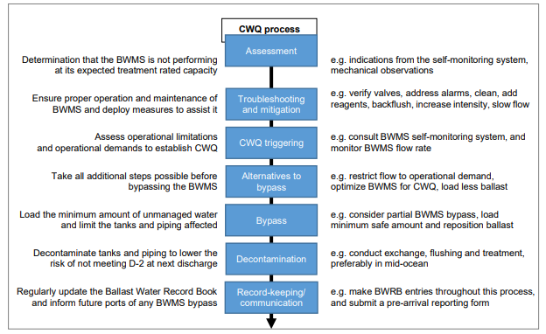

Whenever a full or partial bypass of a BWMS is undertaken, the next State receiving water from affected ballast tanks should be informed of the bypass, such as through a pre-arrival ballast water reporting form5 when such a form is required. Any deviation from the procedures in this Guidance or the BWMP should be noted in the communication.

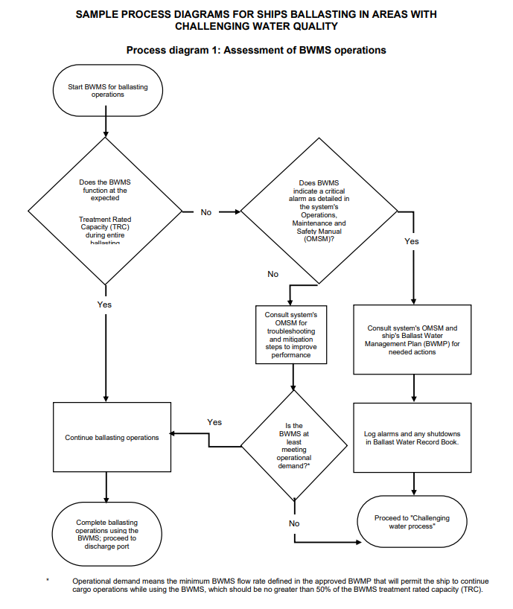

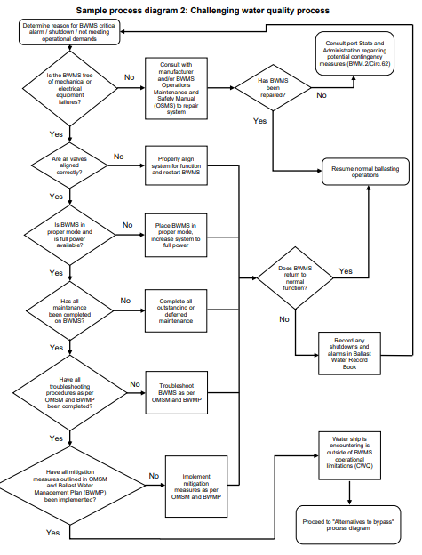

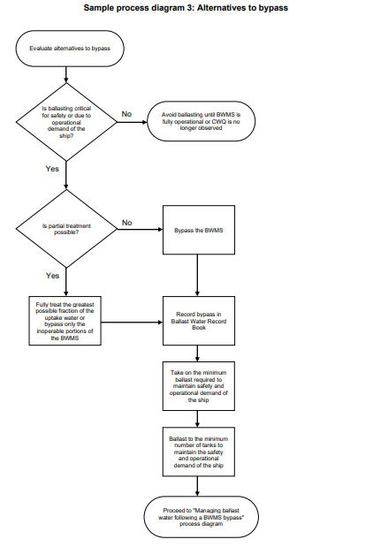

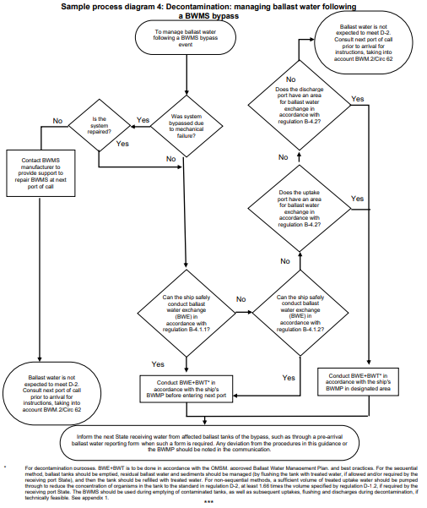

      - CM.1 Repair BWMS at the ballast loading port
This option should be considered if a minor defect of the BWMS is identified and can either be resolved by the
crew or with shore support at the ballast loading port. Service centres for the BWMS used within a company’s
fleet should be known in advance so that emergency contact may be made with the manufacturer’s agents in
each port as required.
If the BWMS treats on uptake then this measure may require a ballast water exchange through the BWMS en
route, as per CM.3.2, to the ballast discharge location to ensure all ballast is treated or to discharge and load
ballast at the terminal to ensure all ballast on board has been successfully treated by the BWMS.

      - CM.2 Repair the BWMS en route
If insufficient time is available at the ballast loading port to fully complete a repair, consideration should be
given to undertaking the repair while en route.

The ballast water on board will then have to be treated by the BWMS to ensure all ballast on board is compliant.Depending on the system design this may require the vessel to undertake a ballast water exchange through the BWMS as per CM.3.2.

      - CM.3 Ballast water exchange (BWE) options
It is important to note that compliance with Regulation D-1 may not be required to be recorded on the ship’s
IBWMC (together with Regulation D-2 compliance) when the relevant ballast water exchange procedure has
been included as a contingency measure in the approved BWMP.

CM.3.1 Mid-ocean ballast water exchange – without BWMS
In the event the BWMS cannot be repaired at the ballast loading port or en route, and with an inoperable BWMS, the BWE should be conducted in accordance with the BWM Convention Regulations B-4 and D-1 as
follows:

Regulation B-4 – Ballast Water Exchange

1. A ship conducting Ballast Water exchange to meet the standard in regulation D-1 shall:

1. whenever possible, conduct such Ballast Water exchange at least 200 nautical miles from the nearest
land and in water at least 200 metres in depth, taking into account the Guidelines developed by the
Organization;
- in cases where the ship is unable to conduct Ballast Water exchange in accordance with paragraph

1.1, such Ballast Water exchange shall be conducted taking into account the Guidelines described in
paragraph 1.1 and as far from the nearest land as possible, and in all cases at least 50 nautical miles
from the nearest land and in water at least 200 metres in depth.

Regulation D-1 – Ballast Water Exchange Standard

1. Ships performing Ballast Water exchange in accordance with this regulation shall do so with an efficiency of
at least 95 percent volumetric exchange of Ballast Water.

2. For ships exchanging Ballast Water by the pumping-through method, pumping through three times the volume of each Ballast Water tank shall be considered to meet the standard described in paragraph 1. Pumping through less than three times the volume may be accepted provided the ship can demonstrate that at least 95 percent volumetric exchange is met.

When undertaking BWE the procedure should follow that specified in the relevant section of the ship’s BWMP
and be specific to the vessel.

The USCG BWE standard in §151.2025, ‘Ballast water management requirements’:

Perform complete ballast water exchange in an area 200 nautical miles from any shore prior to discharging ballast water.
Policy Letter 18-02 states clearly that for BWE to be acceptable to the COTP then the exchange must occur in
area 200 miles from any shore.
CM.3.2 Mid-ocean ballast water Exchange – through the BWMS

In the event that a the BWMS has been repaired but there remains untreated (non-compliant) ballast water on
board, the untreated ballast water may be treated en route by undertaking a ballast water exchange through the BWMS. As the ballast water being discharged may contain invasive species from the ballast loading port (depending on the BWMS design) then it is recommended to follow the procedures details in CM.3.1 in regards the Regulation B-4 and D-1 Convention requirements as well as §151.2025, as necessary. In most cases when a BWMS is used in conjunction with BWE, then the sequential method of BWE will have to be utilised.

This contingency measure may also be considered when a BWMS has been by-passed during uptake due to
challenging water quality in the ballasting port. See the notes on this issue in section 1.1.
      - CM.4 Ballast water exchange in a designated ballast water exchange area
Some States have designated BWE areas that should be used as instructed by the Port State authority upon
communication of the BWMS failure. The IMO lists those States and their designated BWE areas on the GISIS
website:

https://gisis.imo.org/Public/BWM/ExchangeAreas.aspx
      - CM.5 Shore based mobile treatment systems at the ballast discharge port
A number of entrepreneurs are developing mobile shore-based treatment options to act as contingency measures or more permanent options for vessels without BWMS installed. These options are broadly grouped
into three categories:

CM5.1 Using a specifically designed ballast water treatment boat or barge that would either provide the vessel with treated ballast water and/or receive untreated ballast water for treatment. This option is closely aligned to the US requirements, §151.2025(a)(5).

CM5.2 A mobile treatment facility transported on a barge or truck at the ballast discharge port to receive untreated ballast water from the ship.

CM5.3 A small mobile ballast water treatment equipment that can be deployed on a ship by a small riding crew to inject and then mix an active substance into the ballast tanks prior to discharge. A small time would need to be allocated to allow the active substances to work and then a neutralising agent would need to be added prior to discharge.
Communication with the Port State will be necessary to determine if this option exists and the necessary connections and piping required to be able to utilise these options.

      - CM.6 Discharge to a port reception facility at the ballast discharge port
This is one of the options specifically mentioned in the USCG requirements, §151.2025(a)(5). However, with
the exception of Flotta Oil Terminal, Scapa Flow, very few ports have the capability to receive and then treat
ballast water.
Some ports are in the process of implementing a system for receiving and treating ballast water using the methods described in CM.5 above.

      - CM.7 Retain Ballast Water onboard
Not discharging ballast water into Port State waters is one of the options specifically mentioned in the USCG
requirements, §151.2025(a)(4) and may also be an option in other countries and ports.

      - CM.8 Use water from a public water supply (PWS)
This is one of the options specifically mentioned in the USCG requirements, §151.2025(a)(2). The sub-section
states that:
Vessels using water from a PWS as ballast must maintain a record of which PWS they received the water from
as well as a receipt, invoice, or other documentation from the PWS indicating that water came from that system. Furthermore, they must certify that they have met the conditions in paragraphs (a)(2)(i) or (ii) of this section, as applicable, and describe in the BWM plan the procedures to be used to ensure compliance with those conditions, and thereafter document such compliance in the BW record book. Vessels using water from a PWS must use such water exclusively unless the usage is in accordance with § 151.2040 of this subpart.

Vessels using PWS water as ballast must have either:
(i) Previously cleaned the ballast tanks (including removing all residual sediments) and not subsequently
introduced ambient water; or
(ii) Never introduced ambient water to those tanks and supply lines.

It should be noted that only water from a US or Canadian PWS would be acceptable to the USCG. The receipt
of delivery of the PWS should be kept on board and provided to the COTP as necessary.

      - CM.9 Partial ballast water discharge at 12nm from the nearest land (US only)
Specific to the US, experience to date suggests that some COTPs are allowing tankers to partially discharge greater than 12nm from nearest land and then undertake a partial loading operation in the US port.

This contingency measure has commercial implications but may be offered by the COTP as an alternative to no
ballast discharge or cargo loading.

    - Reporting and Reporting Forms
      - Model Reporting Forms
The IMO has taken into account the fact that during the early stages of implementing the BWM Convention the shipping industry is likely to face challenges in operating new equipment. As such, the IMO has issued guidance to Governments and the shipping industry which clarifies the need to build experience during the early stages of implementation. In addition, during this period Governments are encouraged to recognise and respect the challenges that may occur when new equipment fails to meet the desired performance standards. The details of this agreement by the IMO, as contained in IMO Resolution MEPC.290(71), should be known by the ship and brought to the attention of the relevant Port State. The relevant text from the resolution therefore appears on the Model Ballast Water Contingency Measure Request Form as presented in Annex I of this Chapter

A Model BWMS Failure Reporting Form has also been provided in this Chapter, Annex II. This should be used
by the designated officer on board to initiate the process described in section 8.5.1.2 of this chapter.

      - BWMS Repair Plan
The BWMS Repair Plan should be prepared by the BWMS manufacturer in consultation with the company.

The BWMS Repair Plan should provide a schedule with a specific timeline from the BWMS manufacturer as to when the BWMS will be repaired. The schedule for repairs is important as it will allow the owner and the Port State to determine whether this is short term fix or a longer term issue that may impact future port calls.

As a minimum, the BWMS Repair Plan should provide details of:

• the BWMS, its repairs and all previous maintenance and failure history
• the length of time the system has been inoperable
• the suspected cause of failure
• repairs that have already been completed
• details relating to the attempts to repair the BWMS
• the schedule for the proposed repair (corrective action)
• communications between the company and the manufacturer
• other relevant operational data.

See Annex 3 of this chapter

Annex I - Ballast Water Contingency Measure Request Form
The following Ballast Water Contingency Measures Report is submitted taking into account Resolution MEPC.290(71) (adopted on 7 July 2017) on the Experience-Building Phase associated with the BWM Convention, and the agreement that, during the ballast water experience-building phase, a ship should not be penalised (sanctioned, warned, detained or excluded) solely due to an exceedance of the ballast water performance standard described in regulation D-2 of the Convention following use of a ballast water management system (BWMS), provided that:

1. the BWMS is approved in accordance with regulation D-3.1;
2. the BWMS has been installed correctly;
3. the BWMS has been maintained in accordance with the manufacturer’s instructions;
4. the Ballast Water Management Plan approved in accordance with regulation B-1 of the Convention has been followed, including the operational instructions and the manufacturer’s specifications for the BWMS; and
5. either the self-monitoring system of the BWMS indicates that the treatment process is working properly, or the port State has been advised that the BWMS is defective prior to the discharge of any ballast water.

The undersigned therefore submits this request to undertake the described contingency measure in accordance with ‘5’ above and can confirm that the BWMS and the ship meet the requirements in 1, 2, 3 and 4 above. The contingency measure proposed is included in the ships’ Ballast Water Management Plan.

1 COMPANY INFORMATION

1.1 Company name:
1.2 Designated officer:
1.3 Email:
1.4 Tel.:

2 SHIP’S PARTICULARS
2.1 Name of ship:
2.2 IMO Number:
2.3 Master:

3 BALLAST WATER MANAGEMENT SYSTEM
3.1 BWMS Manufacturer:
3.2 BWMS Model:

4 PORT/LOCATION OF BWMS FAILURE
4.1 Country:
4.2 Name of port or area:
4.3 Longitude/Latitude:
4.4 Time and date of occurrence: ______hrs __/__/____ (dd/mm/yyyy)

5 INTENDED BALLAST WATER DISCHARGE
5.1 Country:
5.2 Name of port or area:
5.3 Quantity of ballast water to be discharged (m3):

6 INFORMATION ON THE BWMS FAILURE
6.1 Brief description of failure. Full details are provided in the BWMS Failure Report and the BWMS Repair
Plan, enclosed:

7 ADDITIONAL REMARKS AND INFORMATION

8 PROPOSED CONTINGENCY MEASURE
Insert description of the proposed contingency measure including all relevant details on how the measure will be conducted, as per the details provided in the ship’s BWMP.

Insert additional details relating to the time and location the measure will be conducted, as per the Ballast Water Report Form.

- ADDITIONAL INFORMATION

The following documents are appended to this Form:

1. A completed Ballast Water Report Form as per the recommended format provided in the 2017 Guidelines for Ballast Water Exchange (G6) – Resolution MEPC.288 (71)
For the US, this should be in the format of the National Ballast Information Clearinghouse (NBIC) reporting form.
2. The BWMS Failure Report as submitted by the designated officer in charge on the vessel.
3. BWMS Repair Plan as developed by the BWMS manufacturer in consultation with the company.
4. Certificate of Compliance (IBWMC) with the IMO Ballast Water Management Convention
5. Copy of the BWMS Type Approval Certificate
6. Copies of the Ballast Water Record Book covering at least the previous three ballast water management operations.
7. For the US, USCG approval letter for the system or a USCG Alternate Management System (AMS) letter issued to the vessel.
8. For the US, reference to the relevant crew training documentation as provided in the BWMP should also be included with a clear description of the training for both operation and maintenance of the BWMS.

We invite you to review the information provided together with the proposed contingency measure and advise the undersigned as soon as possible of your consent to undertake the procedure described above.

In the event an alternative measure is proposed or more details are required, please contact the undersigned.

Company representative: ________________________ Date: __/__/____ (dd/mm/yyyy)

Annex 2 - Ballast Water Management System Failure Reporting Form

In accordance with the ship’s Ballast Water Management Plan, the Master or responsible officer, having encountered difficulties in managing ballast water due to the failure of the ballast water management system should forward the information below, together with any supporting documentation, to the company representative.

The information will be used to determine the most appropriate contingency measure to use based on the
ship’s Ballast Water Management Plan.

1. SHIP’S PARTICULARS
1.1 Name of ship:
1.2 IMO Number:
1.3 Responsible officer:

2. BALLAST WATER MANAGEMENT SYSTEM
2.1 BWMS Manufacturer:
2.2 BWMS Model:

3. PORT/LOCATION OF BWMS FAILURE
3.1 Country:
3.2 Name of port or area:
3.3 Longitude/Latitude:
3.4 Time and date of occurrence: ______hrs __/__/____ (dd/mm/yyyy)

4 INFORMATION ON THE BWMS FAILURE
4.1 Description of failure (please include any details of the components that failed):

4.2 Details of actions taken to repair BWMS:

4.3 Total volume of ballast pumped prior to failure:
4.4 Hours BWMS in use prior to failure:
4.5 Tanks treated/partially treated/untreated (T/PT/UT):

Tank*
T/PT/UT

* Refer to vessel BWMP for ballast tank coding
5 PROPOSED CONTINGENCY MEASURE(S)
Based on the Contingency Measures listed in the ships’ BWMP, the following Contingency Measures are proposed for this event:

Contingency Measures listed in the BWMP | Proposed  Measure*
CM.1 Repair BWMS at the ballast loading port
CM.2 Repair the BWMS en route
CM.3.1 Mid-ocean ballast water exchange (BWE) – without BWMS
CM.3.2 Mid-ocean ballast water exchange (BWE) – with BWMS
CM.4 Ballast water exchange in a designated ballast water exchange area
CM.5 Shore based mobile treatment systems at the ballast discharge port
CM.5.1 Ballast water treatment boat or barge
CM.5.2 Mobile treatment facility transported on a barge or truck
CM.5.3 Mobile ballast water treatment equipment
CM.6 Discharge to a port reception facility at the ballast discharge port
CM.7 Retain ballast water onboard
CM.8 Use water from a Public Water System
CM.9 Partial ballast water discharge at 12nm from nearest land (US only)
* Tick as appropriate

6 ADDITIONAL REMARKS AND INFORMATION

Master’s signature ________________________ Date: __/__/____ (dd/mm/yyyy)

Annex 3 - Ballast Water Management System Repair Plan

The BWMS Repair Plan should be prepared by the BWMS manufacturer in consultation with the company.

The BWMS Repair Plan should provide a schedule with a specific timeline from the BWMS manufacturer as to when the BWMS will be repaired. The schedule for repairs is important as it will allow the owner and the Port State to determine whether this is short term fix or a longer term issue that may impact future port calls

1. SHIP’S PARTICULARS
1.1 Name of ship:
1.2 IMO Number:
1.3 Responsible officer:

2. BALLAST WATER MANAGEMENT SYSTEM
2.1 BWMS Manufacturer:
2.2 BWMS Model:

3. PORT/LOCATION OF BWMS FAILURE
3.1 Country:
3.2 Name of port or area:
3.3 Longitude/Latitude:
3.4 Time and date of occurrence: ______hrs __/__/____ (dd/mm/yyyy)

4 INFORMATION ON THE BWMS FAILURE

4.1 Description of failure (please include any details of the components that failed):

4.2 BWMS repairs and all previous maintenance and failure history

4.3 the length of time the system has been inoperable

4.4 the suspected cause of failure

5. REPAIR PLAN
5.1 repairs that have already been completed

5.2 details relating to the attempts to repair the BWMS

5.3 the schedule for the proposed repair (corrective action)

5.4 communications between the company and the manufacturer

5.5 other relevant operational data.

Company representative: ________________________ Date: __/__/____ (dd/mm/yyyy)

